Name Benjamin Gorman

Digestive System Classwork

Match the name of each organ with the letter that represents it on the diagram below.
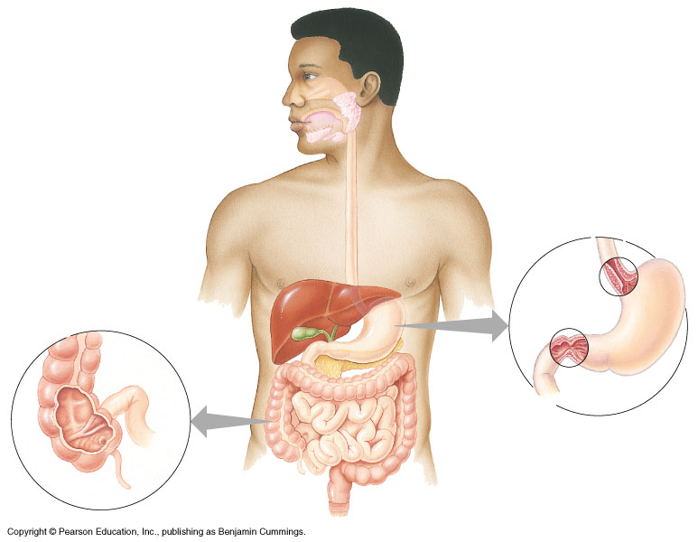
A
B
C
D
E
F
G
H
I
J
K
L
M

k 1. Stomach m 9. Esophagus
e 2. Gall bladder b 10. Tongue
a 3. Oral cavity (mouth) i 11. Small intestine
d 4. Liver l 12. Pharynx (throat)
f 5. Large intestine h 13. Anus
g 6. Rectum
c 7. Salivary glands
j 8. Pancreas
Part 2: Research the following questions:

1. Explain what peristalsis is.
Wave like muscles that push the stuff through acanal.

2. Name 1 organ or accessory gland or organ in the digestive system (no food passes through).
pancreas

Part 3: Using the key choices below, match the description given with the structure that it describes.
A. Gallbladder | D. Villi | G. Large Intestines (Colon)
B. Liver | E. Mouth (Oral cavity) | H. Small intestines
C. Esophagus | F. Pancreas | I. Stomach

a 1. Stores bile until it is secreted.
d 2. Fingerlike extensions in the intestinal wall that increase surface area
c 3. Literally a food chute; connects mouth to stomach
f 4.Produces digestive juices such as insulin.
h 5. Organ responsible for absorption of most nutrients (longest part of digestive system).
g 6. Organ primarily involved in water absorption and feces formation.
b 7. Produces bile.
e 8. First part of the digestive system
i 9. Contains strong acids for breaking down food

Part 4: Answer in complete sentences. Provide evidence and examples.
Compare and contrast mechanical digestion and chemical digestion and give an example of an organ for each.

Mechanical digestion is chewing the food and chemical digestion is when the saliva breaks down the food.

